**Office Hours**

**Office Hours**: We will be holding virtual office hours on Microsoft Teams in the General channel. You can “join” the meeting and ask any questions you have or just say hi!

* This is a meeting open to all students in the class.
* We will work with students on their individual questions in the order that you join and post your first question.
* You can drop into the meeting at any point during the posted office hours. There is no particular need to show up right at the beginning of the office hours. However, be aware that if we run out of time to answer your questions, you will have to attend another office hours meeting or email your question.

**To join the meeting:**

1. Log-into our class Team and navigate to the **General** channel.
2. To join the video chat, you should see a big purple bar with a Join button. Click that button and then make the following choices:
   1. **Camera toggled off**
   2. **Microphone toggled off**
   3. **Then click Join**

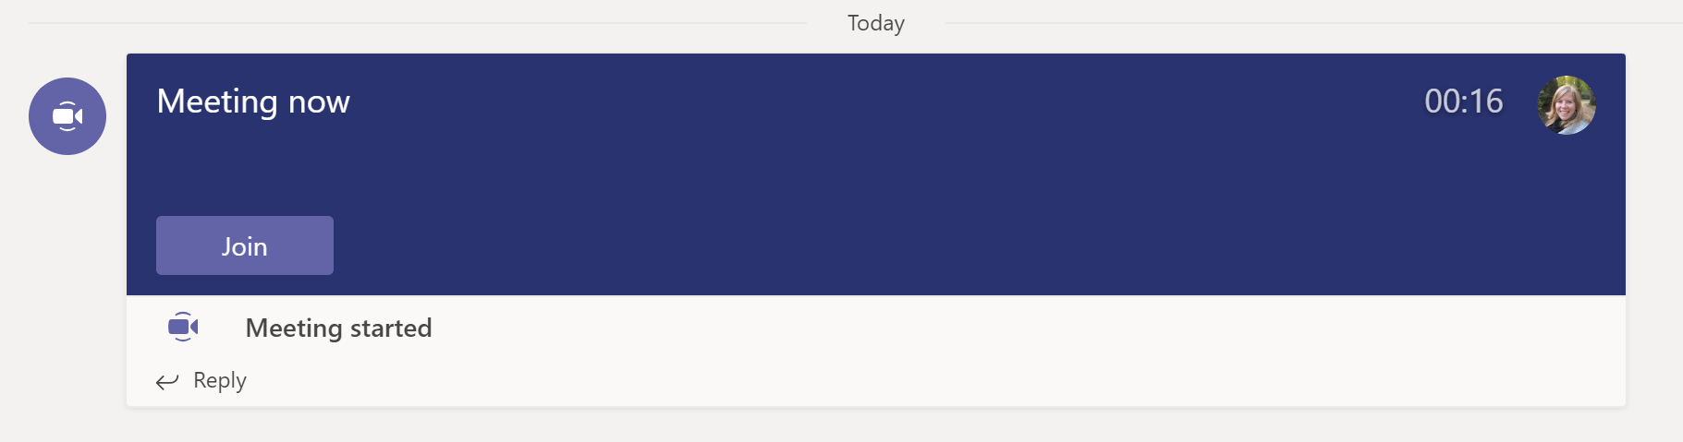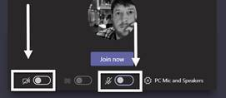

1. Once in the meeting, please open the chat bar by clicking on the speech bubble in your floating toolbar. Type your first question in there. For example, you could type, “Question about locating files.”

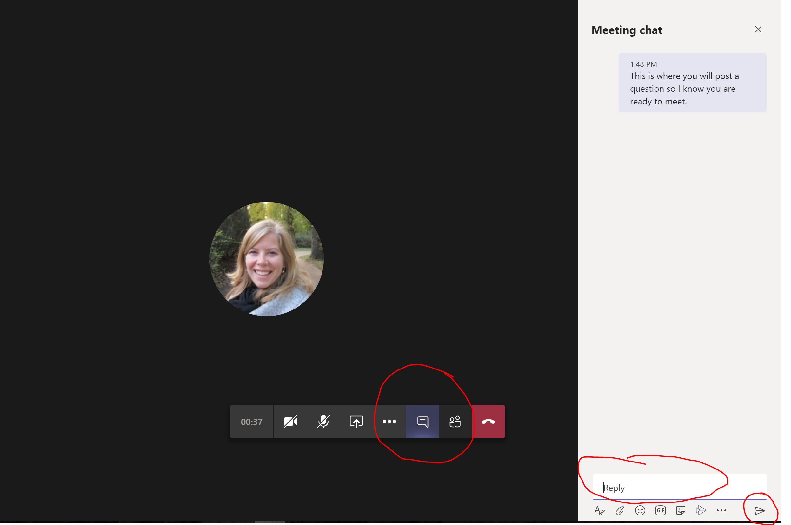

1. We will work with individuals in the order they join, but all are welcome to stay and listen.
2. The teacher will call your name and you can unmute your mic to ask your question.