Unit 06 - Nisei Daughter
Notes and Reading Questions

Major Characters | Characteristics/Notes  (*continue filling out as you read the book)
Mr. and Mrs. Itoi
Monica “Kazuko” Sone
Henry (older brother)
Kenji (youngest brother)
Sumiko (sister)

Important Terms:

Directions: Match the following terms with their definition. Write the definition on the corresponding lines.

Sei = _______________________
Third Generation
First Generation
Prefectural Associations
Generation
Third Generation

Issei = _______________________

Nisei = _______________________

Sansei = _______________________

Kenjinkai = _______________________
- Local entities
- Governmental bodies of _______________ which are larger than cities, towns, and villages

- Monica’s parents are _______________________

- Monica and her siblings are ___________________________

Issei | Nisei
- Men and women were mostly  __________________ years old when immigrating to America. | - Born in America, granted citizenship as _____________ right.
- ____________________ for US citizenship (permanent alien status) | - They were Americans, spoke ___________  - Idealized American ________________  - Went to American _______________
- Obeyed the custom “of the __________ structure of Japanese society, the tendency to grant special rights, privileges, and ____________ to those in higher status” (x) | - Isolated from ____________ ________________ society still, and also had limited participation in Japanese culture because they didn’t speak language fluently or understand traditions.
 | - “A Nisei was American, but not truly part of American society. A Nisei was certainly not Japanese, but Japanese influences seeped into aspects of his character and behavior” (xi-xii)

Historical Context:

Immigration Act of 1924:
Immigration and Nationality Act of 1952
HR 442 and SB 1009
Skid Row
Japanese Association
“The outbreak of war between Japan and the United States, and the evacuation of the Japanese minority, drastically changed the status of the Nisei” | “ ____________________”
Ten Internment/Concentration Camps
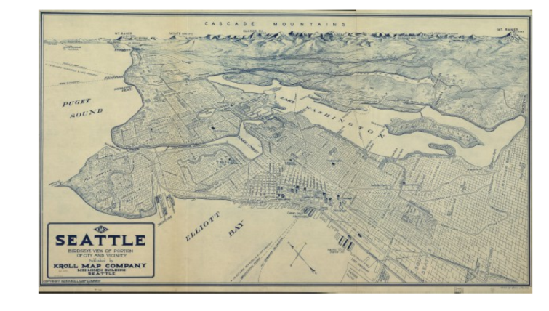

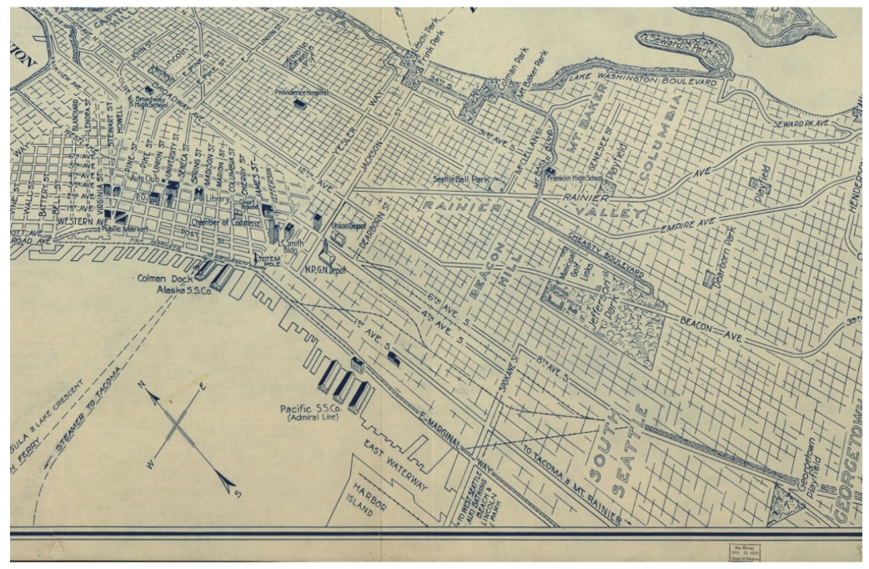

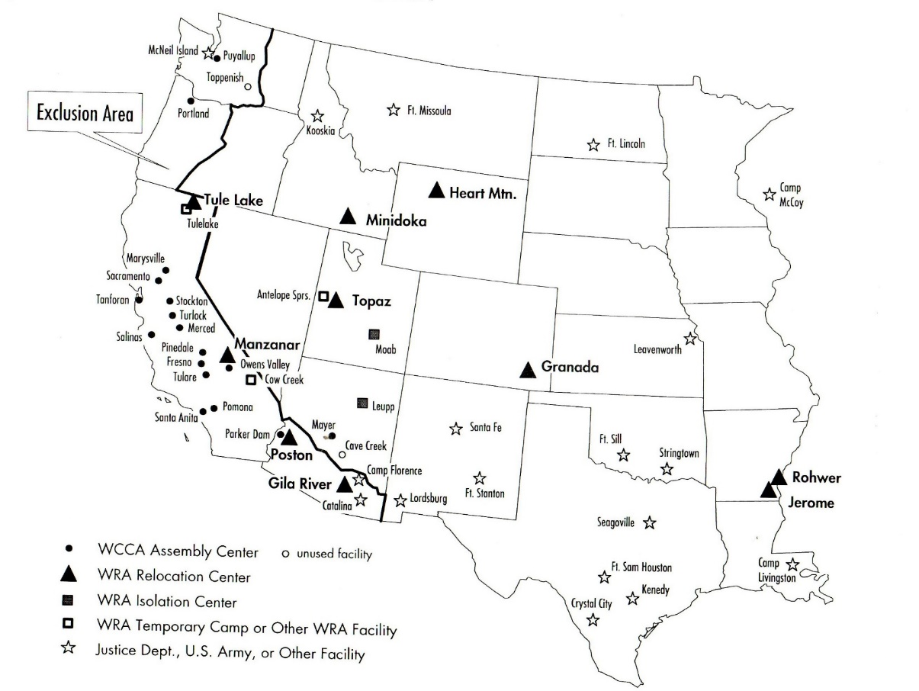

Map of War Relocation Authority Centers for detained Japanese Americans.

