19 April 2020
Dear Students,
These next nine weeks are going to be an adventure!
I honestly cannot express how sad I am that we will not be returning to campus this year and that I won’t get to see your smiling faces, listen to your goofy jokes, or hear your weekly updates. I truly miss each and every one of you. That being said, I know this is a difficult time and although we cannot see each other in person, please know that I am still here for you.
In regard to school, I am excited to begin this new learning process with you all and truly learn alongside you! I am sure we will all experience some bumps in the road, but I will do my best to navigate those bumps and be flexible to accommodate your needs.
I am not going to lie, distance learning and quarantine can feel pretty dang lonely. It might be difficult to get into the swing of learning at home or you may easily feel overwhelmed/frustrated by technology. Remember everyone feels emotions differently. Do not be afraid to take a breaks to refocus. Don’t give in to the frustration or give up. I care about your mental health and well-being. Reach out if you need to!
With being at home, learning will look less structured than learning at school. You are more responsible for being accountable for your learning. Although I cannot physically make you do the work, we have worked hard to narrow our remaining time with essential learning and skills that will benefit you for the future. Make sure you check my website and follow the week-at-a-glance calendar frequently. Your success is important to me!
Most of all, know that I believe in you and you will get through this. We will get through this together.
Let’s rock the last 9 weeks we have together!

Sincerely,
Ms. Magee
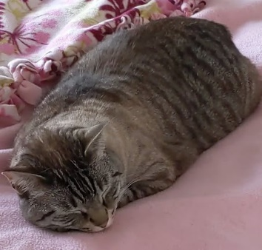
Ms. Magee’s cat Luna

